- Please stay in assigned areas of playground.
- Stay away from stairwells, hallways, or near classroom doors.
- Stay off of the basketball court.
- Stay away from areas where P.E. classes are in session.
- Do not bounce balls against the school building.
- No dodgeball or American football (soccer is permitted).
- Please be kind and considerate to all students on the playground.
- Listen to teachers.
- If you are injured, send a friend to report the accident to the nearest teacher.
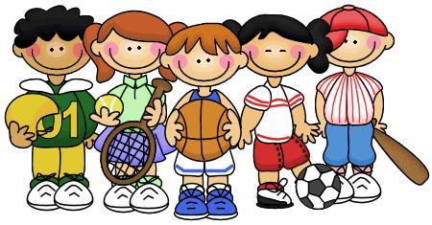
- Line up when the whistle blows at the end of recess.

